Library Management System
Requirement Document v0.1

Prepared by
Velocity Software Solutions Pvt. Ltd.
Website: www.velsof.com,
E-mail: inquiry@ velsof.com, nsrivastava2@ velsof.com
E-23, Sector-63, Noida. Phone: +91-120-4243310
Contents
Introduction 3
1. Login 4
2. Book List 5
2.1. Add Book 6
2.2. Edit Book 7
3. Issue List 8
3.1 Issue Book 9
4. Student List 10
4.1. Add Student 11

Introduction

The project titled Library Management System is Library Management software for monitoring and controlling the transactions in a library .The project “Library Management System” will be developed in asp.net using c#, which mainly focus on basic operations in a library like
1. Book List: Display a list of existing books in library.
2. Add Book: Add new book in the library
3. Issue List: Display a list of issued book with student name, whom the book is issued
4. Issue Book: Issue a book to a student
5. Student List: Display list of Student.
6. Add Student: Add a new student in the student list.
This project of “LIBRARY MANAGEMENT” gives us the complete information about the library. We can enter the record of new books and retrieve the details of books available in the library. We can issue the books to the students and maintain their records.

1. Login

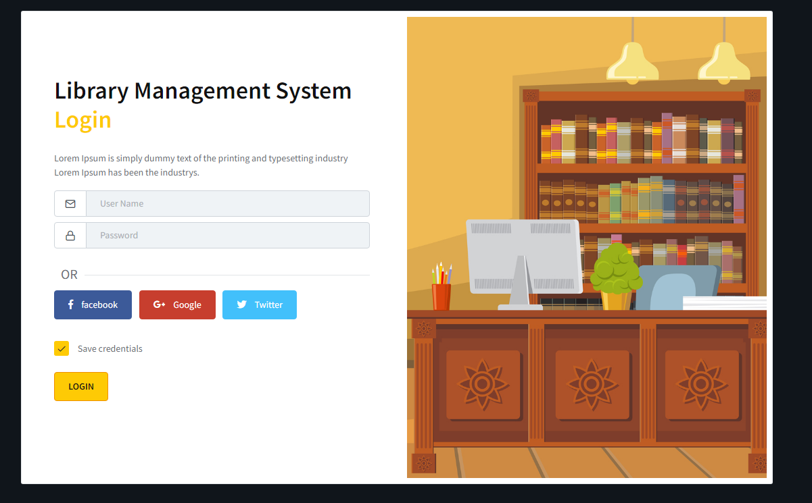
Login Button

User will enter the credentials in the Login page. If the details are correct then the page will redirected to the Book list page.
User will also able to login in the system through Facebook login.
Note: For New and Forgotten Username and Password contact to administration.
2. Book List
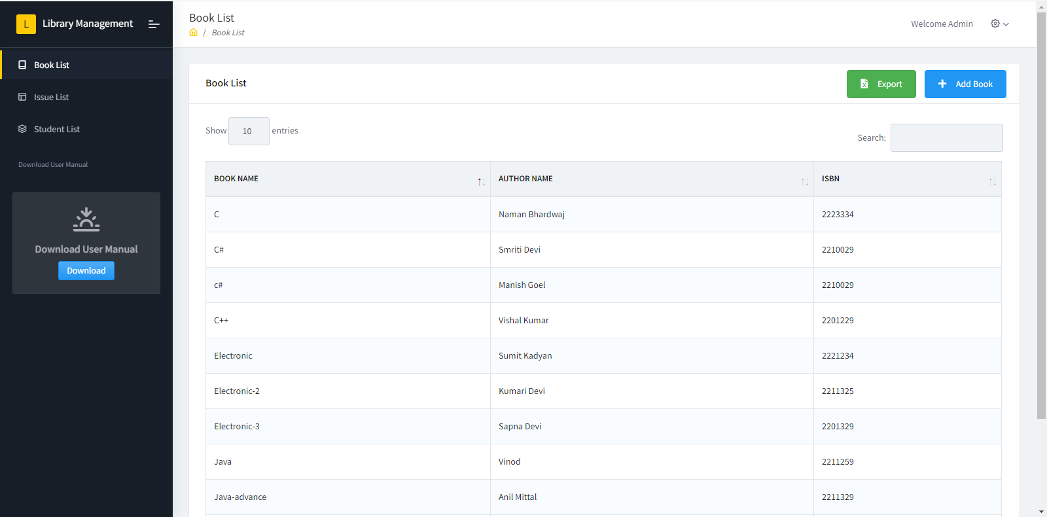
Add Book Option

On Left side there are menu options: Book List, Issue List, Student List and Download User Manual. User will able to access all these pages according to the requirement.

There will be a grid in the page which contains the details of book i.e. Name, Author Name and ISBN.
There is one action column after ISBN.
In that column an Edit icon will shown from where user will able to edit the details of each book.

There will be Add book option in the page from that button user will able to add a new book in the system.

2.1. Add Book
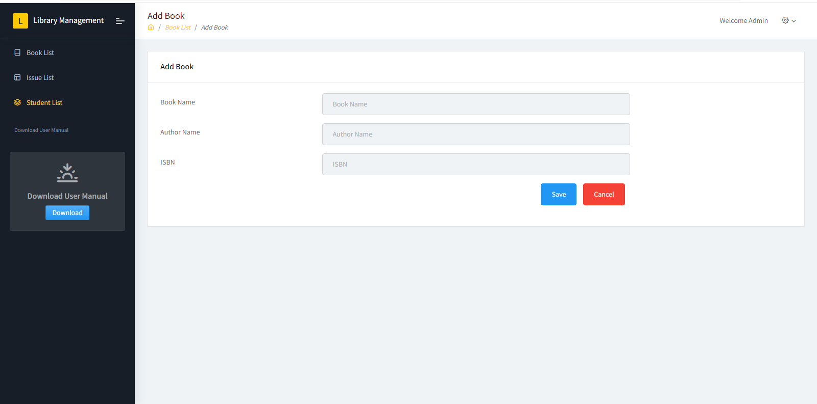

To add a new book user will have to enter Book Name, Author Name and ISBN in the provided text fields and press save button.
Application will check whether the Book Exist or not in existing list with same ISBN. If Book Exist then show the error message will be shown else user will be redirect to the Book List page and new Book added in the List. Success Message displayed in Book List page.

On Cancel option click user will go back to Book List page without adding new book.

2.2. Edit Book
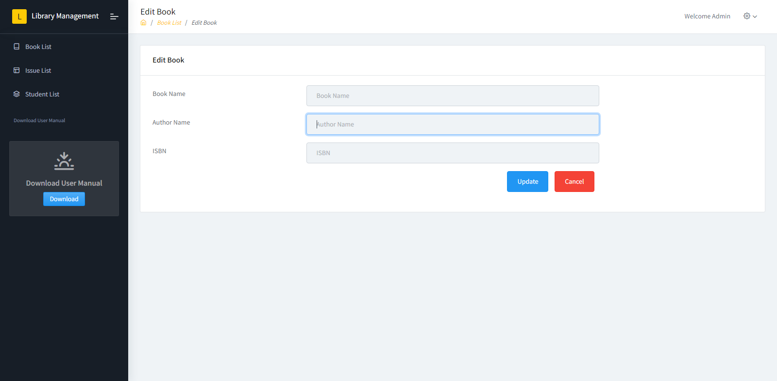

User will enter Book Name, Author Name and ISBN which he wants to update in the provided text fields and press Update button.
Application will check whether the Book Exist or not in existing list with same ISBN. If Book Exist then show the error message will be shown else user will be redirect to the Book List page and new Book added in the List. Success Message displayed in Book List page.

On Cancel option click user will go back to Book List page without updating any book details.

3. Issue List

Issued Book List displayed in the grid with column: Id, Book Name, Student Name (whom book is issued), return date, return option

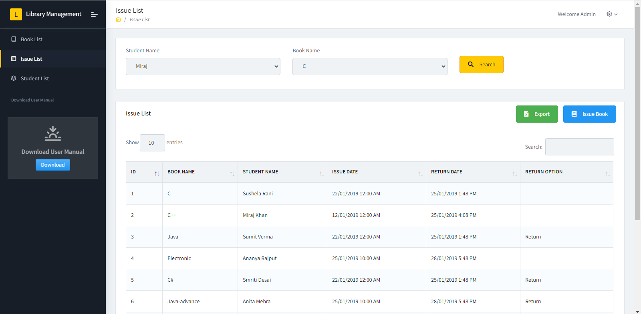
Two drop downs available for doing the searching in the grid. First dropdown is selecting for Student Name and second dropdown is selecting for Book Name.
On Click of Search button, grid will bind the values on the basis of the selected values in both dropdown.
Return option only show for the books that has status "issue". To set return status click on return option then book status change to return and entry with current date and time updated in Issue List.
On Click of Issue Book button new page will be open.

3.1 Issue Book

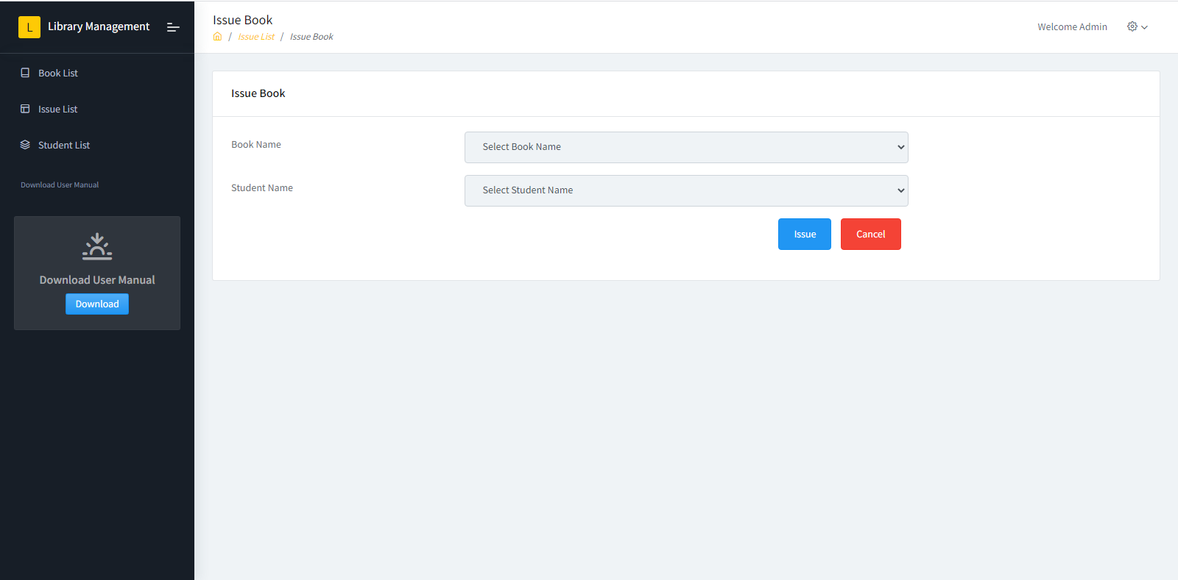
To issue a book to a student you have to select Book Name from Book Name drop down and Student name from Student Name drop down.
Then On click of Issue button application check for entry of selected book on the name of selected person exist or not. If exist then show error message for that else issued selected book on name of selected student and redirect to the issue list page.
On click of cancel button redirect to the issue list page without issue the book.

4. Student List

Student List displayed in grid with column: Image, id, Student Name Roll No. , Phone No., Download Option. On Download Link click download the image of student from row in which download option in clicked.

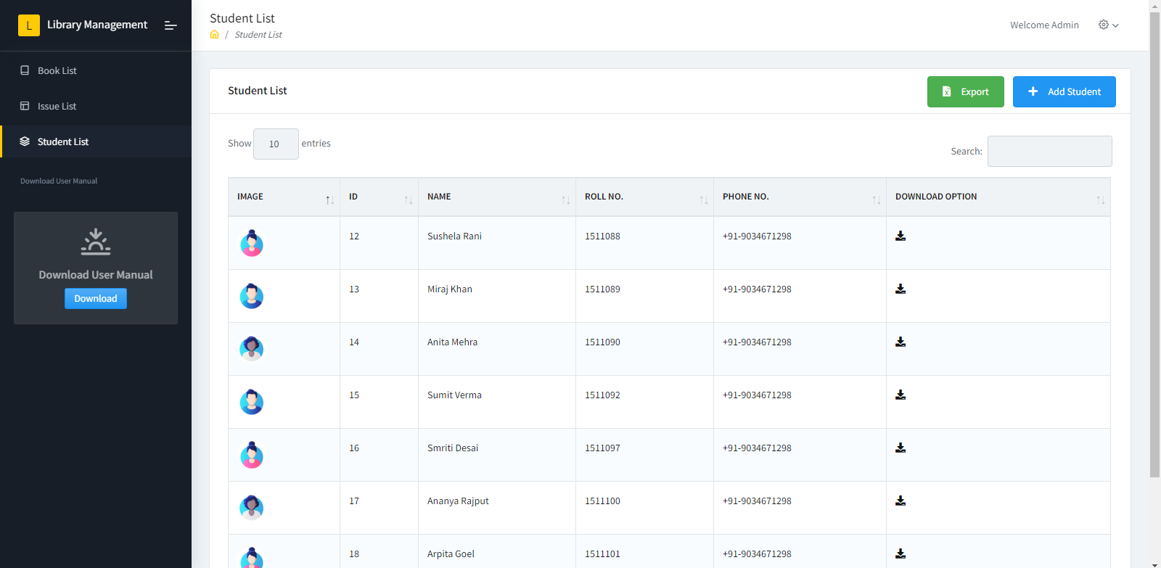

On Export button click export the data of student list into excel sheet.
On Add Student button click redirect to the new page.

4.1. Add Student

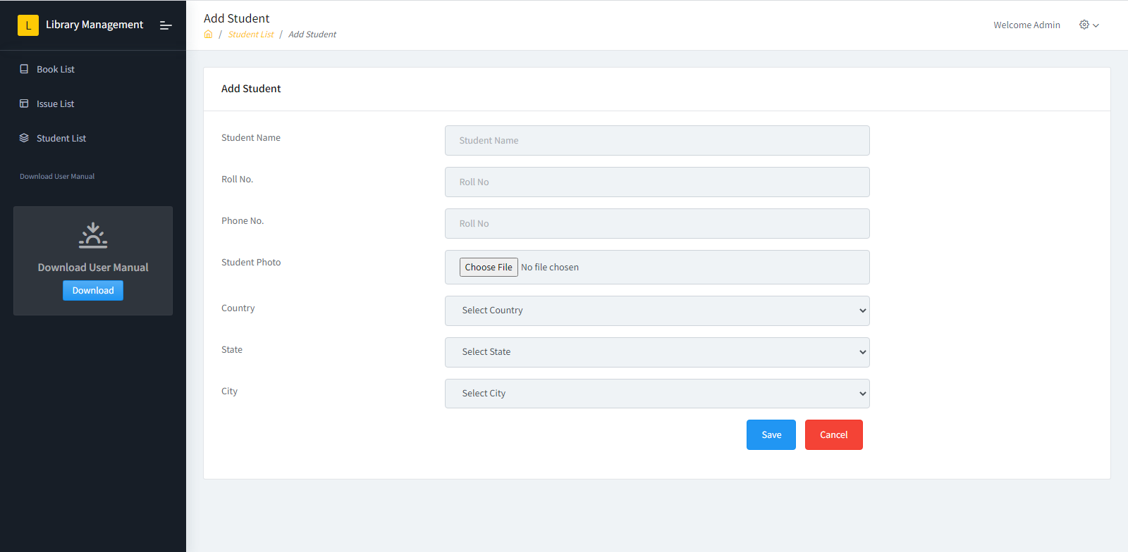
To add new student enter the following information of student: Student Name, Roll No, Phone No. , Select Photo, select Country, Select State, Select City. After clicking on Save button new student will be added in list and redirect to the Student List page.
State dropdown only have state that comes under country selected in country drop down. Similarly city drop down have city that comes under state selected in state drop down.
On Cancel option click redirect to the student List page without adding new student in list.

While uploading the profile image, the file name of the images to be uploaded in the system should be unique. Append the time stamp after the name of the file. Save only the file name in the database and upload the image in the application folder.

Note: Click On the Left hand side Download User Manual Option to Download User Manual of Library Management System.

